**Lab 08: Setup up an Assembly Language Project in MPLAB**

**Lab Objective:**

In this lab, you will learn about creating an assembly language project in MPLAB and embed it with proteus simulation.

**Lab Description:**

After installing MPLAB and Proteus in your PCs, follow the following steps shown below. These will show you how to make a project in MPLAB. Follow the step-by-step procedure as shown below to compile your code and embed it with Proteus.

1. Select Project Wizard from Project tab.

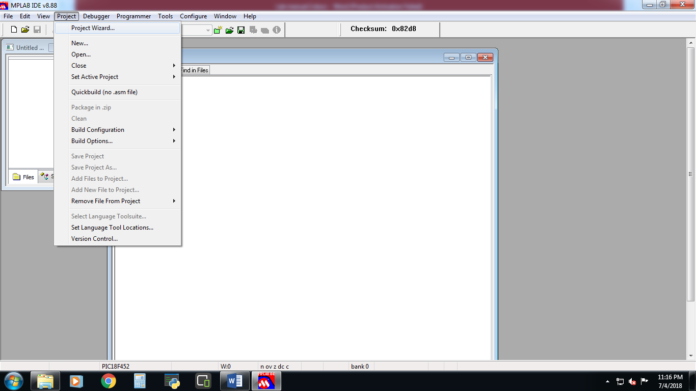

1. Click Next.

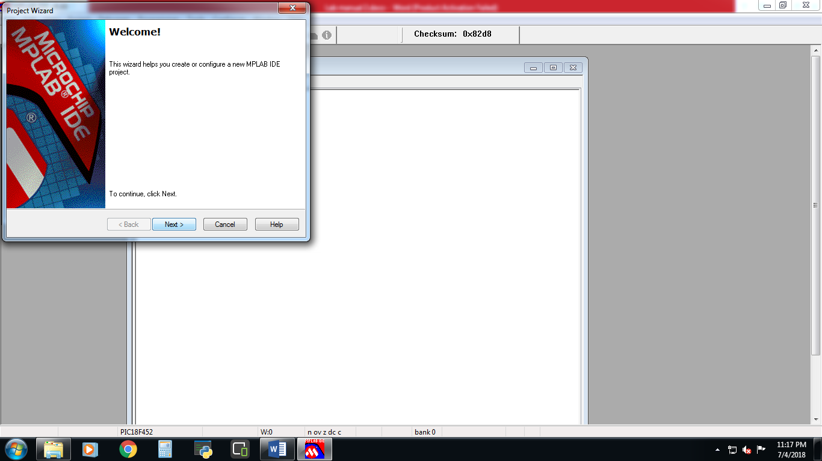

1. Select PIC18f452 from the devices

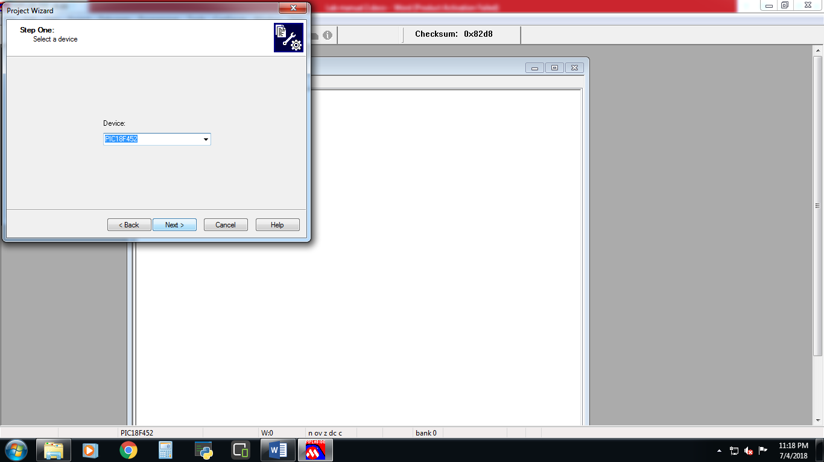

1. Select MSASM as assembly compiler.

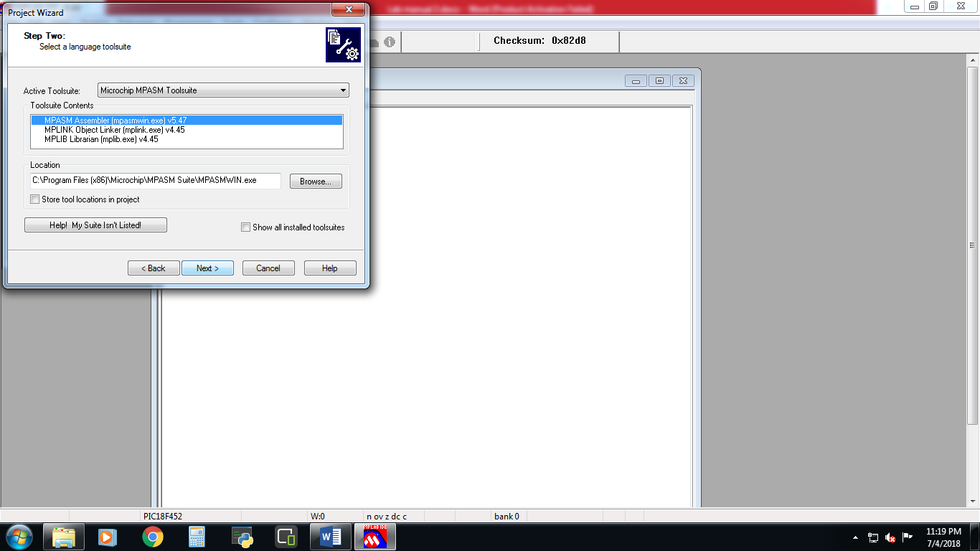

1. Click browse to set path for your new project.

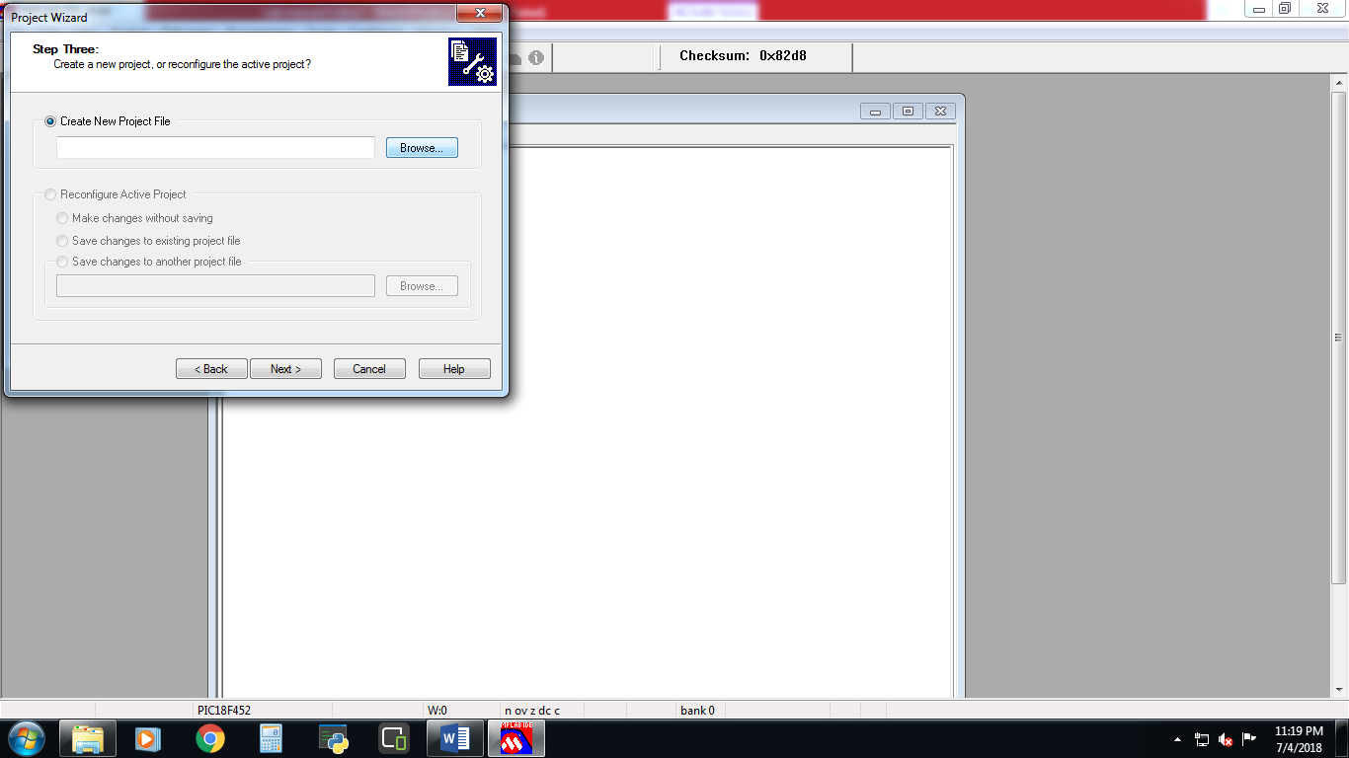

1. Select folder and file name for your project.

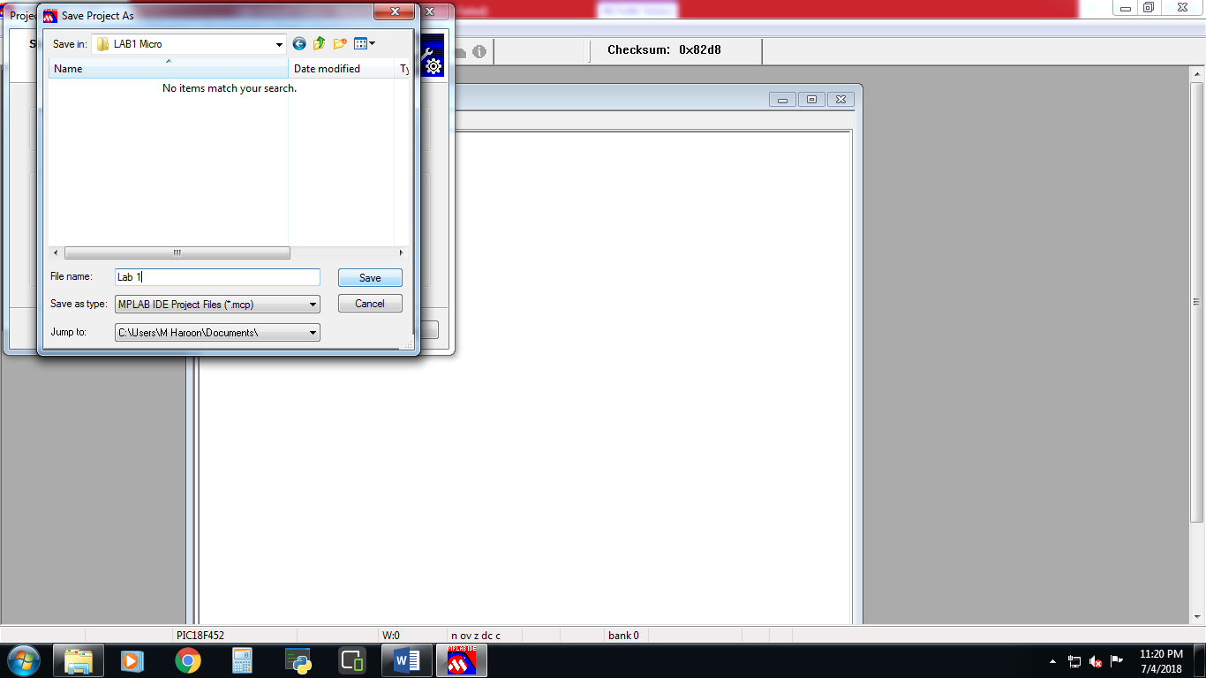

1. Click Next.

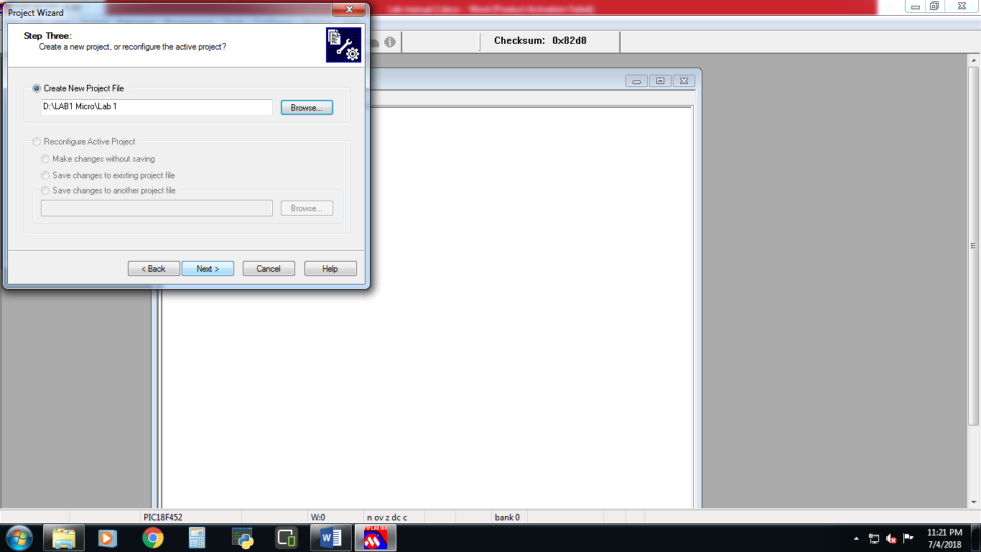

1. Select the following two files and add them in your project.

**C:/Program Files/ Microchip/ Mpasm Suite/ p18f452.inc**

**C:/Program Files/ Microchip/ Mpasm Suite/ LKR / 18f452_g.lkr**

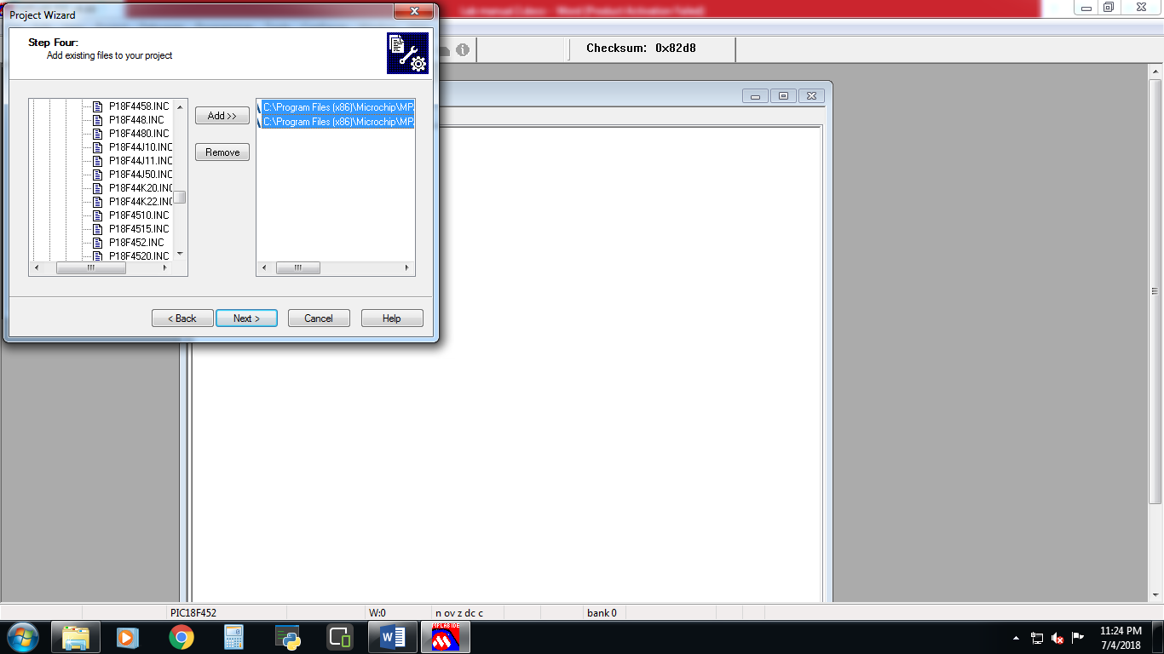

1. Click ‘New File’ icon to create a new file.

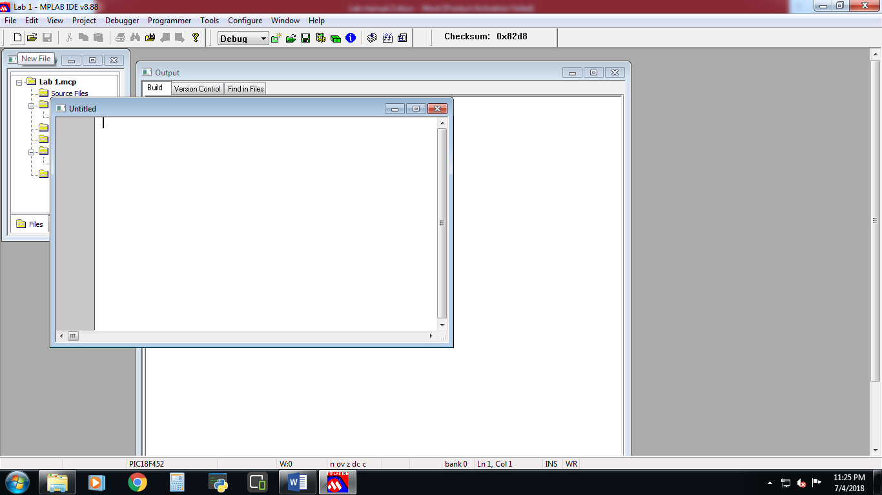

1. Save that file with the extension .asm (you’ll have to type .asm)

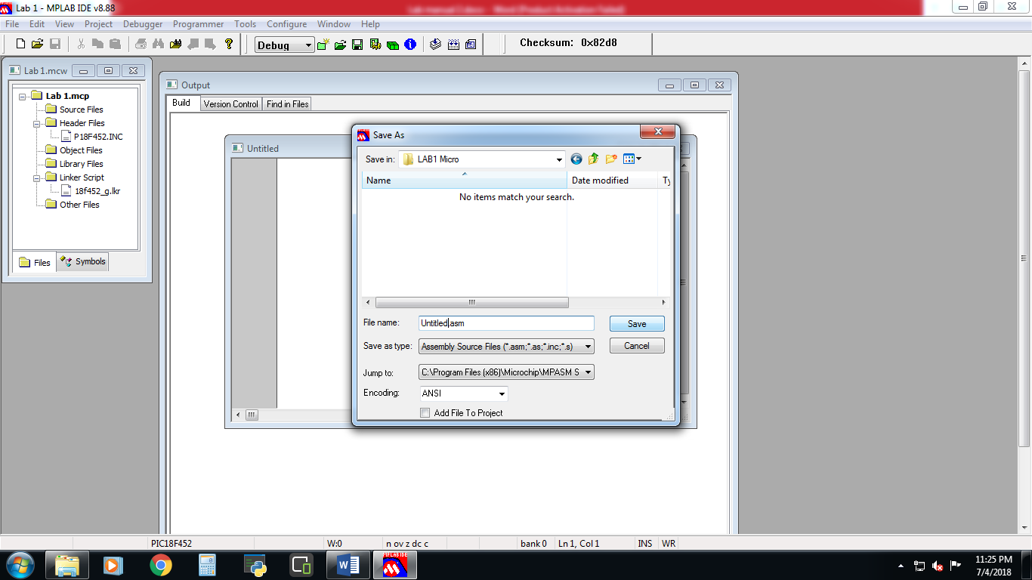

1. Right click Source File and click on Add Files…

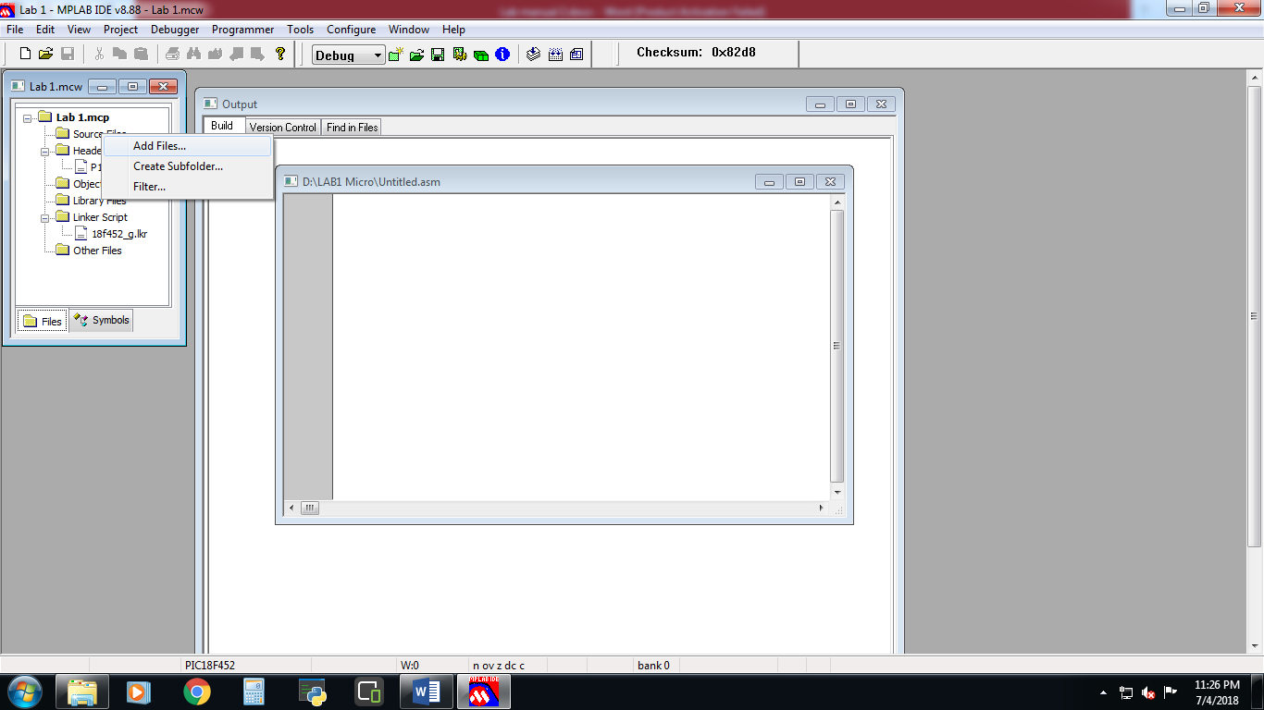

1. Select the .asm file that you saved earlier.

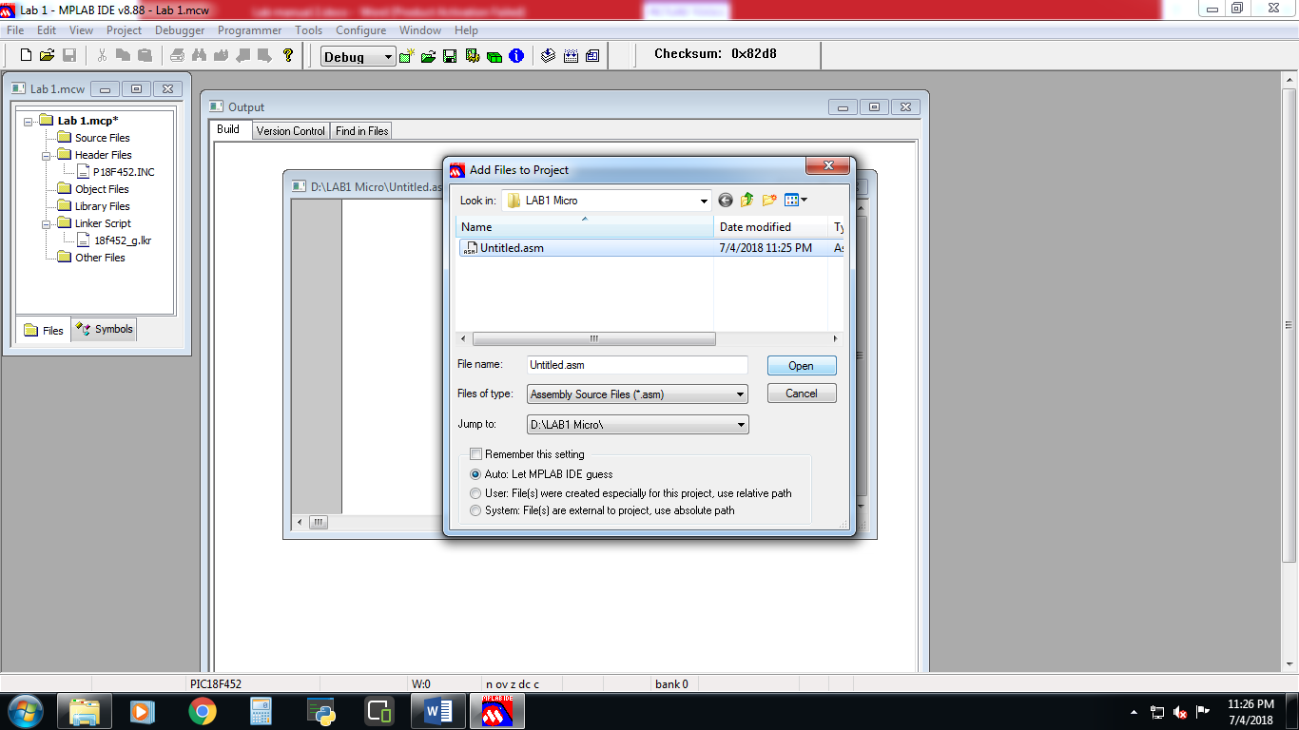

1. Write a code in you .asm file and click on build all icon to build the project.

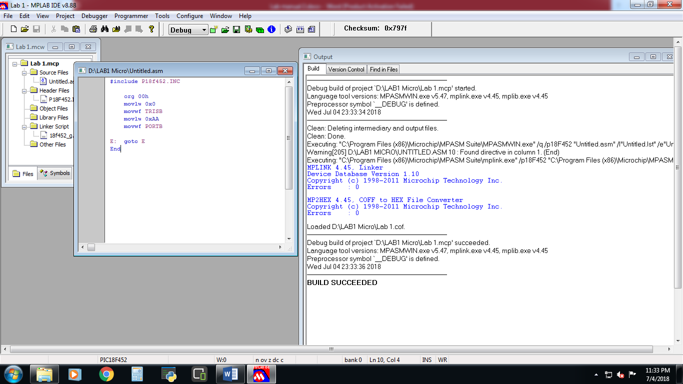

1. In your Proteus, create the following circuit schematic diagram.

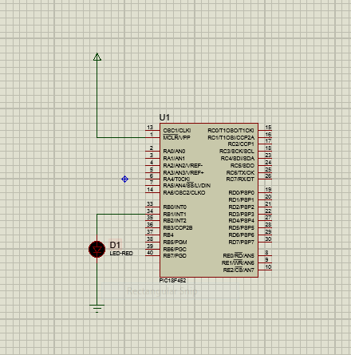

1. In your proteus schematic, double click on PIC18F452 IC then select .hex file as program file.

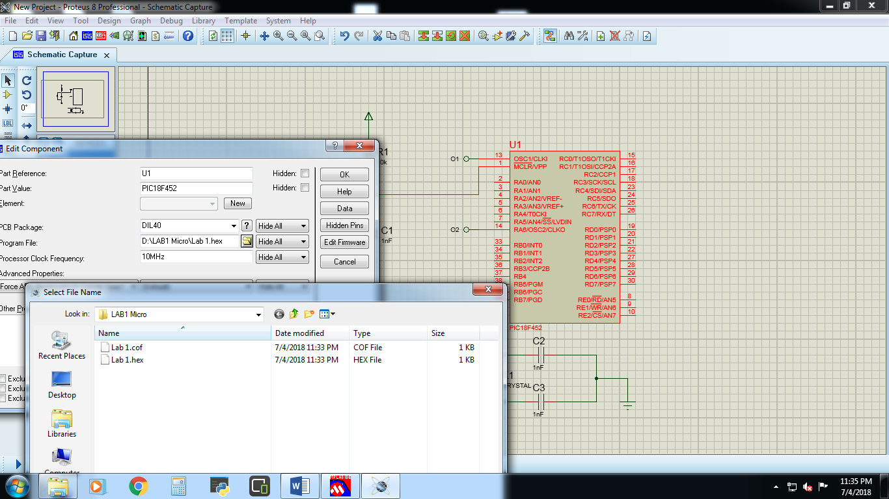

1. Now, simulate the circuit and observe the output.

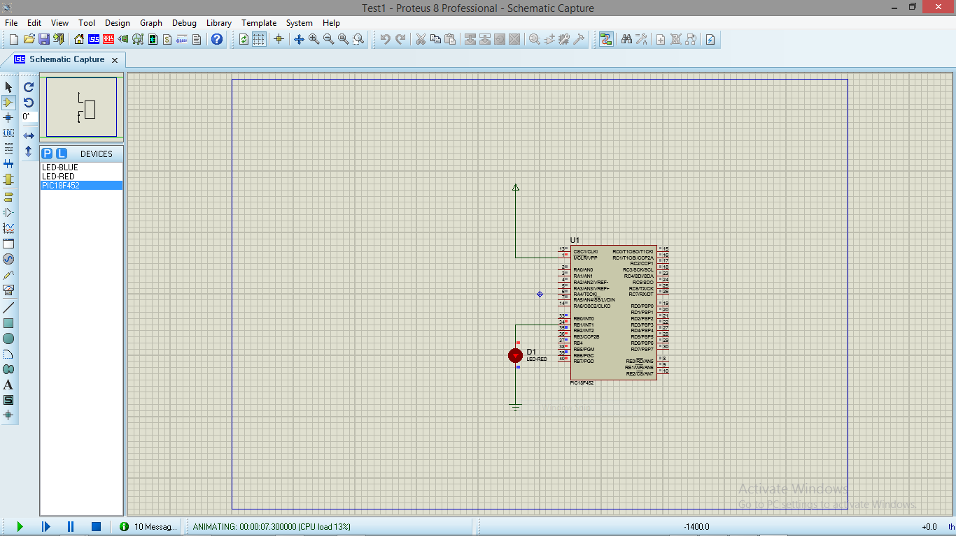

**Lab Task:**

Perform the above mentioned steps, modify the above code and show toggling of LED in Proteus.